**QUIZ RESULTS**

**MODULE 5: REGULARIZATION DETAILS**

|  |  |  |  |  |
| --- | --- | --- | --- | --- |
| **No.** | **Quiz title** | **Completion Status** | **Score** | **Coursera link** |
| 1 | Module5_Practice Quiz_ Details of Regularization | Completed | 100% | [Quiz 1](https://www.coursera.org/learn/supervised-machine-learning-regression/assignment-submission/hwDSo/practice-quiz-details-of-regularization/view-feedback) |
| 2 | Module5_Regularization Details | Completed | 100% | [Quiz 2](https://www.coursera.org/learn/supervised-machine-learning-regression/assignment-submission/zI0lV/module-5-graded-quiz-regularization-details/view-feedback) |

# Module5_Practice Quiz_ Details of Regularization

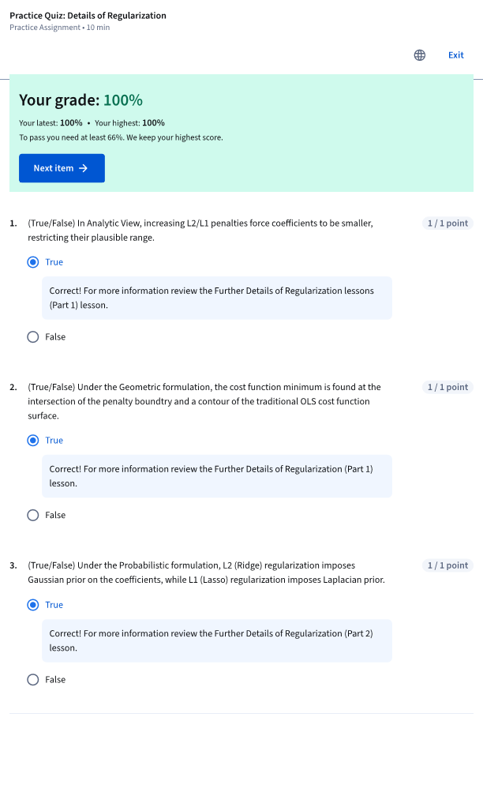

# Module5_Practice Quiz_ Polynomial Features and Regularization

